**Introduction**

R package [rfm](https://rfm.rsquaredacademy.com/)  
go into the conceptual details of RFM analysis. In this post, we  
will explore RFM in much more depth and work through a case study as well.  
**RFM** (Recency, Frequency & Monetary) analysis is a behavior based technique  
used to segment customers by examining their transaction history such as:

* how recently a customer has purchased?
* how often do they purchase?
* how much the customer spends?

It is based on the marketing axiom that **80% of your business comes from 20%  
of your customers**. RFM helps to identify customers who are more likely to  
respond to promotions by segmenting them into various categories.

**Case Study**

We will work through a case study to better understand the underlying concepts  
of RFM analysis. To pique your curiosity, we will start with the results or  
the final outcome of the case study as shown below:



The table has the following details:

* name or id of the customer
* number of days since the last transaction of the customer
* number of transactions of the customer
* total value of the all the transactions of the customer
* RFM score
* customer segment

The rest of this post will focus on generating a similar result for our case  
study and along the way we will learn to:

* structure data for RFM analysis
* generate RFM score
* and segment customers using RFM score

**Applications**



Let us talk about applications. Though largely identified with retail or  
ecommerce, RFM analysis can be applied in a lot of other domains or industry as  
well. In social media and apps, RFM can be used to segment users as well. The  
only difference is instead of using monetary value as the third metric, we will  
use the amount of time spent (or some other metric based on it) on the site/app.  
The more time we spend on the platform and consume the content, the more ads  
can be displayed by the platform. So in those cases, the amount of time we  
spend will be the third metric.

**RFM Workflow**



The typical workflow for RFM analysis is shown above. It can be broadly divided  
into the following:

* In the first step of the workflow, we **collect transaction data**. This  
  should include a unique customer id, transaction date and transaction amount. In  
  case of ecommerce, we need to decide how to treat visits that did not result in  
  a transaction. If data is aggregated and made available at the customer level,  
  it must include a unique customer id, last transaction date and total revenue  
  from the customer. The last transaction date may be replaced by days since last  
  visit as well. The details available in data supplied depends on the data  
  pipeline and the rfm package can handle any of the above 3 scenarios.
* In the second step, we **generate RFM table** from the raw data available. The  
  RFM table aggregates data at the customer level. It includes the unique customer  
  id, days since last transaction/visit, frequency of transactions/visits and the  
  total revenue from all the transactions of the customer.
* In the third step, we **generate scores** for recency, frequency and monetary  
  value, and use them to create the RFM score for each customer.
* In the final step, we use the recency, frequency and monetary scores to  
  **define customer segments** and design customised campaigns, promotions,  
  offers & discounts to retain and reactivate customers.

**RFM Table**

Let us assume we have completed the first step in RFM analysis by collecting  
transaction data. Now, we have to generate the RFM table from the transaction  
data. In the transaction data, each row represents a transaction and we may get  
the transaction details in any of the following ways:

* according to transaction date
* sorted by customer id
* or in a random order

The first two cases are more likely but if we get the transaction data in a  
random order, the first order of business is to sort them by customer id. In  
the below example, we have transaction details for 3 customers Lionel, Jaineel  
and Taj but they are not sorted by transaction date or customer id. Since we  
want to create the RFM table from this data, we sort it by customer id.



From the sorted data, we aggregate the transaction details at the customer level  
as shown below.



From the above step, we have created the RFM table which contains recency (days  
since last visit), frequency (frequency of visits) and monetary (total revenue  
from the customer) data for each customer.



**Metrics**

Time to talk about the key metrics **R**ecency, **F**requency and **M**onetary  
in more detail. In this section, we will understand how they are calculated,  
and in the next section, we will learn how they are used for generating the  
RFM score.



**Recency**

Let us begin with recency. Earlier, we defined it as the number of days since  
the last transaction of the customer. How do we calculate this metric? Apart  
from the date of the last transaction of the customer, what other information  
do we need? In all the discussions till now, we have missed out on a key point  
i.e. the time frame of the analysis.

The most crucial step in RFM analysis is to select a time frame from which  
we use the transaction data. How do we decide on this time frame? It depends  
on the domain to which we are applying this analysis. Customers visit a grocery  
store more often than they visit a consumer durables store. Similarly, people  
consume content from news & blogs more frequently while they may visit an  
e-commerce website only when they have to purchase something. Keeping in mind  
the domain to which the analysis is being applied, select an appropriate time  
frame. To calculate recency, compute the difference between the last transaction  
date and the analysis date i.e. the last date of the selected time frame.



In the above example, the analysis date is 2016-12-31. To compute recency,  
we first extract all the transaction date of customer Taj and then select the  
last transaction date, 2015-04-21, and subtract if from the analysis  
date to get the number of days since the last transaction date, 620.

**Frequency**

Frequency is the count of transactions. In the online/digital world, we need to  
decide whether we will consider all the visits to a website or app as the  
frequency or only those which resulted in a transaction/conversion. In the  
below example, we count the transactions for each customer and use it as  
frequency. Lionel has 6 transactions, Jaineel has 9 transactions and Taj has  
4 transactions.



**Monetary Value**

Monetary value is the total revenue from each customer in the selected time  
frame. It is computed by summing up the transaction amount. In our case study,  
Jaineel has spent the highest amount of $843, followed by Lionel who has  
spent $472 and Taj has spent the lowest, $196. As you can observe, we have  
arrived at these figures by summing the values in the third column of the  
second table, Order Amount.

If we are applying this analysis to the digital world, we may think of using  
a metric such as time spent on the website/app instead of transaction/order  
amount.



**RFM Score**

As shown in the workflow, the third step in RFM analysis is to generate the  
individual score for each metric and then use them to generate the RFM score. In  
this section, we will explain in detail how the scores are computed for recency,  
frequency and monetary. This section is slightly complex (we received a lot of  
mails from readers after we published the previous post) and we have tried our  
best to break down the complexity as much as possible.

We follow the below steps to create the score:

* use quantiles to generate cut off points
* create intervals based on the cut off points
* use the intervals to assign score

**Monetary Score**



Let us generate the monetary score in our case study. The first step is to  
compute the quantiles using the quantile() function. We use the revenue  
column from the RFM table to compute the quantiles. If you look at the example,  
it gives us the cut off below which a certain percentage of customers are  
present.

* the bottom 20% of customers spend below $254.8.
* the next 20% of customers spend between $254.8 and $381.0.
* the top 20% of customers spend above $665.0.

Using these cut off points we have created intervals which can then be converted  
to if else statements. The intervals are then used to assign scores. For  
example, Lionel falls in the interval > 381.0 & <= 505.4 and hence is assigned  
the score 3. Similarly, Jaineel and Taj are assigned the scores 5 and 1.  
How do we interpret the scores? The score is more like a rank. A customer with  
a score of 3 is ranked higher than a customer with score of 1 as his transaction  
amount is higher. In the rfm package, we use the above method to assign the  
scores.

Some users reverse the order of the score i.e. top 20% customers by transaction  
amountare assigned the score 1 and the bottom 20% are assigned the score 5.

**Frequency Score**



The frequency score is computed in the same way as the monetary score. Instead  
of using the revenue column from the RFM table, we use the frequency column.  
Using quantiles, we arrive at the cut off points below which a certain  
percentage of customer are present. If you observe the example, the first table  
shows the quantiles and the associated cut off points.

* the bottom 20% of customers visit/transact less than 3 times.
* the next 20% of customers visit/transact around 4 times.
* the top 20% of customers visit/transact more than 7 times.

The cut off points are then used to create the intervals and assign the scores  
as shown in the second table. We assign a higher score to those who visit more  
frequently and a lower score to those who visit less frequently.

In our case study, Jaineel has visited 9 times and hence assigned the score 5  
where as Taj has visited only 4 times and hence the score 2.

**Recency Score**

The recency score follows the same methodology but uses a slightly different  
concept while assigning the score. If you look at the metrics, the higher the  
values of frequency and monetary, the better as we want customers to transact  
frequently and spend higher amount but it is not the case with recency. Since  
recency represents the number of days since the last transaction, the lower its  
value the better i.e. customers who visited in the recent past are more likely  
to visit again whereas customers who visited long back may be as good as lost.  
Hence in the case of recency, higher score is assigned to those with lower  
recency value and vice versa.



In the above example, we have used quantiles to compute the cut off point for  
recency. The first table shows the quantiles and the associated cut off points:

* the bottom 20% of customers visited more than 481 days back.
* the next 20% of customers visited between 296.4 and 481 days back.
* the top 20% of customers visited less than 114 days back.

The above statements will become clear if you study the second table which  
includes the interval and the score. We have assigned a higher score to those  
who visited in the recent past (< 114 days) compared to those who visited way  
back (> 481 days). In our case study, Jaineel visited in the past 3 months and  
hence the score of 5 where as Taj visited almost 20 months back and has been  
assigned the score 1.

[youtube ad](https://www.youtube.com/user/rsquaredin/)

**RFM Score**

Now that we have calculated the individual scores, let us compute the RFM score  
using the below formula:

RFM Score = Recency Score * 100 + Frequency Score * 10 + Monetary Score

The below table shows the individal scores of recency, frequency and monetary as  
well as the RFM score. All of them are computed from the RFM table which in  
itself is based on the transaction data.



**Segments**

Great! We have finally computed the RFM score. Now what? How do we define the  
segments using this score? In this section, we will learn how to define customer  
segments using the RFM score. The below table is an example of how segments are  
defined. It has the following details:

* the name of the segment
* the definition of the segment
* the intervals for the recency, frequency & monetary scores

We should be careful while creating the intervals for the scores in the  
segments table.



Let us apply the above rules to our case study.



Defining segments is another crucial step in RFM analysis. We need to ensure  
that there is no duplication or large number of customers get classified into  
Others segment. In the case study, we will show you some of the mistakes  
that can happen while defining the segments.

**Case Study**

It is time to work through the case study. Let us first load all the libraries we  
will use as shown below:

library(rfm)

library(dplyr)

library(magrittr)

library(lubridate)

**Data**

To calculate the RFM score for each customer we need transaction data which should include the following:

* a unique customer id
* date of transaction/order
* transaction/order amount

rfm includes a sample data set rfm_data_orders which includes the above  
details:

rfm_data_orders

## # A tibble: 4,906 x 3

## customer_id order_date revenue

##

## 1 Mr. Brion Stark Sr. 2004-12-20 32

## 2 Ethyl Botsford 2005-05-02 36

## 3 Hosteen Jacobi 2004-03-06 116

## 4 Mr. Edw Frami 2006-03-15 99

## 5 Josef Lemke 2006-08-14 76

## 6 Julisa Halvorson 2005-05-28 56

## 7 Judyth Lueilwitz 2005-03-09 108

## 8 Mr. Mekhi Goyette 2005-09-23 183

## 9 Hansford Moen PhD 2005-09-07 30

## 10 Fount Flatley 2006-04-12 13

## # ... with 4,896 more rows

**RFM Score**

Use rfm_table_order() to generate the score for each customer from the sample  
data set rfm_data_orders.

rfm_table_order() takes 8 inputs:

* data: a data set with
  + unique customer id
  + date of transaction
  + and amount
* customer_id: name of the customer id column
* order_date: name of the transaction date column
* revenue: name of the transaction amount column
* analysis_date: date of analysis
* recency_bins: number of rankings for recency score (default is 5)
* frequency_bins: number of rankings for frequency score (default is 5)
* monetary_bins: number of rankings for monetary score (default is 5)

**RFM Table**

analysis_date <- lubridate::as_date("2006-12-31", tz = "UTC")

rfm_result <- rfm_table_order(rfm_data_orders, customer_id, order_date, revenue, analysis_date)

rfm_result

| **customer_id** | **date_most_recent** | **recency_days** | **transaction_count** | **amount** | **recency_score** | **frequency_score** | **monetary_score** | **rfm_score** |
| --- | --- | --- | --- | --- | --- | --- | --- | --- |
| Abbey O’Reilly DVM | 2006-06-09 | 205 | 6 | 472 | 3 | 4 | 3 | 343 |
| Add Senger | 2006-08-13 | 140 | 3 | 340 | 4 | 1 | 2 | 412 |
| Aden Lesch Sr. | 2006-06-20 | 194 | 4 | 405 | 3 | 2 | 3 | 323 |
| Admiral Senger | 2006-08-21 | 132 | 5 | 448 | 4 | 3 | 3 | 433 |
| Agness O’Keefe | 2006-10-02 | 90 | 9 | 843 | 5 | 5 | 5 | 555 |
| Aileen Barton | 2006-10-08 | 84 | 9 | 763 | 5 | 5 | 5 | 555 |
| Ailene Hermann | 2006-03-25 | 281 | 8 | 699 | 3 | 5 | 5 | 355 |
| Aiyanna Bruen PhD | 2006-04-29 | 246 | 4 | 157 | 3 | 2 | 1 | 321 |
| Ala Schmidt DDS | 2006-01-16 | 349 | 3 | 363 | 2 | 1 | 2 | 212 |
| Alannah Borer | 2005-04-21 | 619 | 4 | 196 | 1 | 2 | 1 | 121 |

rfm_table_order() will return the following columns as seen in the above table:

* customer_id: unique customer id
* date_most_recent: date of most recent visit
* recency_days: days since the most recent visit
* transaction_count: number of transactions of the customer
* amount: total revenue generated by the customer
* recency_score: recency score of the customer
* frequency_score: frequency score of the customer
* monetary_score: monetary score of the customer
* rfm_score: RFM score of the customer

**Segments**

Let us classify our customers based on the individual recency, frequency and  
monetary scores.

| **Segment** | **Description** | **R** | **F** | **M** |
| --- | --- | --- | --- | --- |
| Champions | Bought recently, buy often and spend the most | 4 – 5 | 4 – 5 | 4 – 5 |
| Loyal Customers | Spend good money. Responsive to promotions | 2 – 4 | 3 – 4 | 4 – 5 |
| Potential Loyalist | Recent customers, spent good amount, bought more than once | 3 – 5 | 1 – 3 | 1 – 3 |
| New Customers | Bought more recently, but not often | 4 – 5 | < 2 | < 2 |
| Promising | Recent shoppers, but haven’t spent much | 3 – 4 | < 2 | < 2 |
| Need Attention | Above average recency, frequency & monetary values | 3 – 4 | 3 – 4 | 3 – 4 |
| About To Sleep | Below average recency, frequency & monetary values | 2 – 3 | < 3 | < 3 |
| At Risk | Spent big money, purchased often but long time ago | < 3 | 2 – 5 | 2 – 5 |
| Can’t Lose Them | Made big purchases and often, but long time ago | < 2 | 4 – 5 | 4 – 5 |
| Hibernating | Low spenders, low frequency, purchased long time ago | 2 – 3 | 2 – 3 | 2 – 3 |
| Lost | Lowest recency, frequency & monetary scores | < 2 | < 2 | < 2 |

**Segmented Customer Data**

We can use the segmented data to identify

* champion customers
* loyal customers
* at risk customers
* and lost customers

Once we have classified a customer into a particular segment, we can take  
appropriate action to increase his/her lifetime value.

[packages ad](https://pkgs.rsquaredacademy.com/)

**Segment Size**

Now that we have defined and segmented our customers, let us examine the  
distribution of customers across the segments. If our segmentation logic is  
good, few or no customer should be categorized as Others.

segments %>%

count(segment) %>%

arrange(desc(n)) %>%

rename(Segment = segment, Count = n)

## # A tibble: 12 x 2

## Segment Count

##

## 1 At Risk 157

## 2 Potential Loyalist 132

## 3 Others 128

## 4 Champions 116

## 5 Need Attention 100

## 6 Hibernating 97

## 7 About To Sleep 92

## 8 Lost 75

## 9 Loyal Customers 43

## 10 Promising 21

## 11 Can't Lose Them 17

## 12 New Customers 17

We can also examine the median recency, frequency and monetary value across  
segments to ensure that the logic used for customer classification is sound and  
practical.

**Median Recency**

rfm_plot_median_recency(segments)

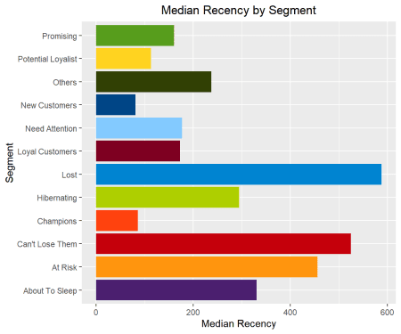

**Median Frequency**

rfm_plot_median_frequency(segments)

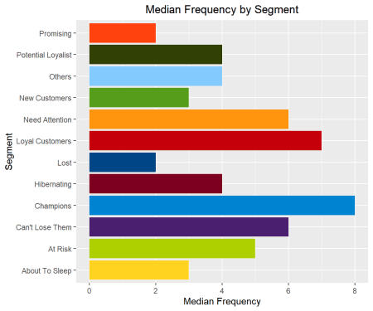

**Median Monetary Value**

rfm_plot_median_monetary(segments)

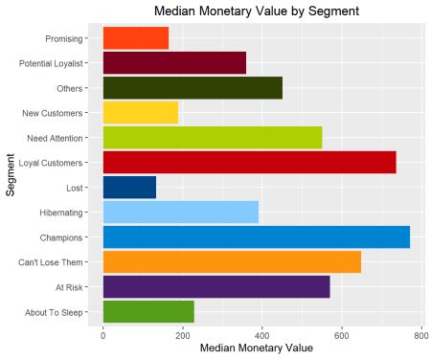

**Heat Map**

The heat map shows the average monetary value for different categories of  
recency and frequency scores. Higher scores of frequency and recency are  
characterized by higher average monetary value as indicated by the darker areas  
in the heatmap.

rfm_heatmap(rfm_result)

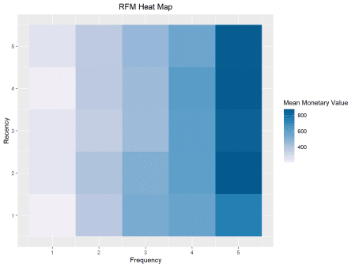

**Bar Chart**

Use rfm_bar_chart() to generate the distribution of monetary scores for the  
different combinations of frequency and recency scores.

rfm_bar_chart(rfm_result)

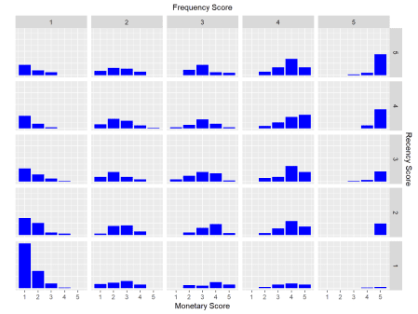

**Histogram**

Use rfm_histograms() to examine the relative distribution of

* monetary value (total revenue generated by each customer)
* recency days (days since the most recent visit for each customer)
* frequency (transaction count for each customer)

rfm_histograms(rfm_result)

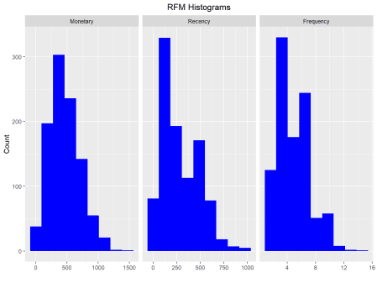

**Customers by Orders**

Visualize the distribution of customers across orders.

rfm_order_dist(rfm_result)

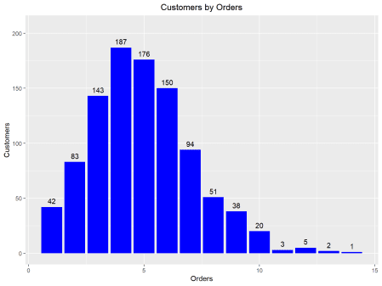

**Scatter Plots**

The best customers are those who:

* bought most recently
* most often
* and spend the most

Now let us examine the relationship between the above.

**Recency vs Monetary Value**

Customers who visited more recently generated more revenue compared to those  
who visited in the distant past. The customers who visited in the recent past  
are more likely to return compared to those who visited long time ago as most  
of those would be lost customers. As such, higher revenue would be associated  
with most recent visits.

rfm_rm_plot(rfm_result)

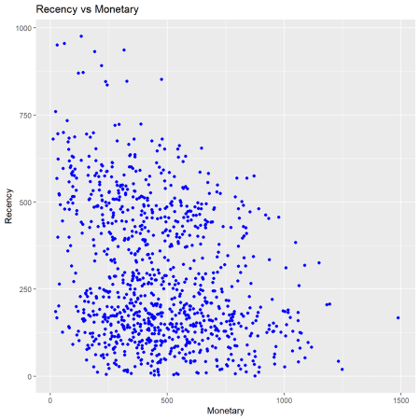

**Frequency vs Monetary Value**

As the frequency of visits increases, the revenue generated also increases.  
Customers who visit more frquently are your champion customers, loyal customers  
or potential loyalists and they drive higher revenue.

rfm_fm_plot(rfm_result)

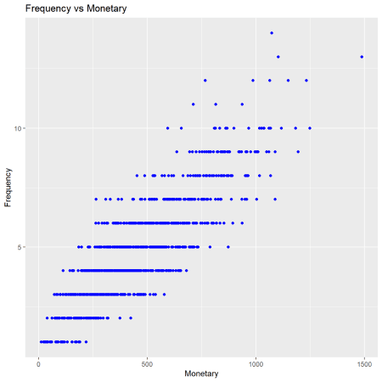

**Recency vs Frequency**

Customers with low frequency visited in the distant past while those with high  
frequency have visited in the recent past. Again, the customers who visited in  
the recent past are more likely to return compared to those who visited long  
time ago. As such, higher frequency would be associated with the most recent  
visits.

rfm_rf_plot(rfm_result)

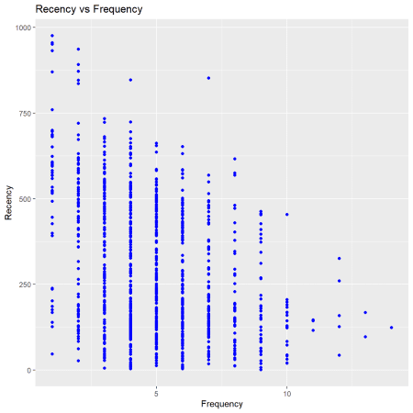

**Your Turn…**

* if you look at the distribution of segments, around 13% of the customers  
  are in the Others segment For segmentation to be effective and optimal, the  
  Others segment should be eliminated or should have few customers only.  
  Redefine the segments and try to reduce the number of customers in the Others  
  segment.
* we have defined 11 segments. Try to combine some of the existing segments  
  and bring down the total segments to around 6 or 8.
* the RFM score we generated uses score between 1 and 5. Try to create segments  
  by using a score between 1 and 3 i.e. the lowest RFM should be 111 and the  
  highest should be 333 instead of 555.
* reverse the scores i.e. so far we have assigned a score of 5 to customers who  
  visited recently, frequently and had higher transaction amount and 1 to  
  customers who visited way back, rarely and have low transaction amount. Reverse  
  this score pattern and create the segments.